SYLLABUS 2018-2019
BIOLOGY

Instructional Goals:

- To make science interesting, meaningful, and engaging for students.
- Utilize different learning modalities and various educational media to teach State Standards.
- Place importance on effort. Provide a well-managed classroom and laboratory.

Students will investigate biological systems at the molecular, cellular, and macro-biological level. Hands-on laboratory exercises incorporating cellular biology, genetics, DNA technology, evolution, and ecology will be provided to assist students in their understanding of biological themes. Projects and reading assignments may be required with each unit of instruction.

Instructor: Ms. Renee Barnett
Phone / Remind: Enter this number 81010 Text this message @a2b4cg
Email: Renee.barnett@browardschools.com

Contact and school web site: http://lauderhill612.browardschools.com/
Click on ‘Faculty Contacts’ at the top then choose ‘science’ -> scroll to Renee Barnett.
ClassWebsite: www.barnettlovesscience.weebly.com

Textbook: Available through Broward Single Sign on.
Go to online textbooks. Select Science, Secondary Science, Biology, then
HMH. Student Resources also available through Canvas. .

Policies follow the Code of Student Conduct set forth by Broward County Schools, and are available on-line. The Code of Conduct Acknowledgment must be signed and returned. Keep in mind that these rules, responsibilities, and policies are to facilitate your success!

Classroom rules
1. Show Respect. 4. Arrive to class on time.
2. Demonstrate Responsibility. 5. Follow directions, procedures, & rules
3. Always TRY! 6. Complete & turn in all assignments on time.
7. Remain in class for the duration of the period.

Lab and Lab Safety will be reviewed in class. Lab safety contracts must be signed & returned, and a pass grade on the Lab Safety Test must be achieved in order to participate in labs. Students who do not wear appropriate safety equipment and/ or do not follow directions may not be allowed to participate and will receive a ZERO for lab due to the emphasis placed on creating a safe environment for all students. Labs missed may not be able to be repeated. It is the student’s responsibility to see me for a make-up assignment that directly correlates with the topic and complexity of the lab missed.

Biology (core) Syllabus
Course Syllabus follows Broward County’s Biology Instructional Focus Calendar covering:
*Dates Subject to Change. *Pre/Post Tests are from District C.A.R.E. Packages. Dates are Tentative. Post-Test Dates TBD by Pacing* **Semester 2 topic progression rearranged to maximize instructional time on ecology concepts which covers 40% of Bio EOC Exam**
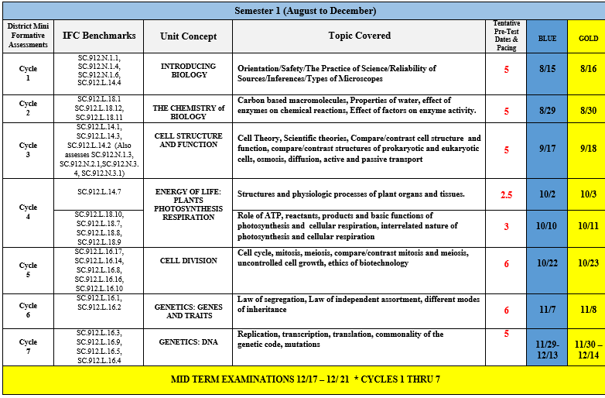

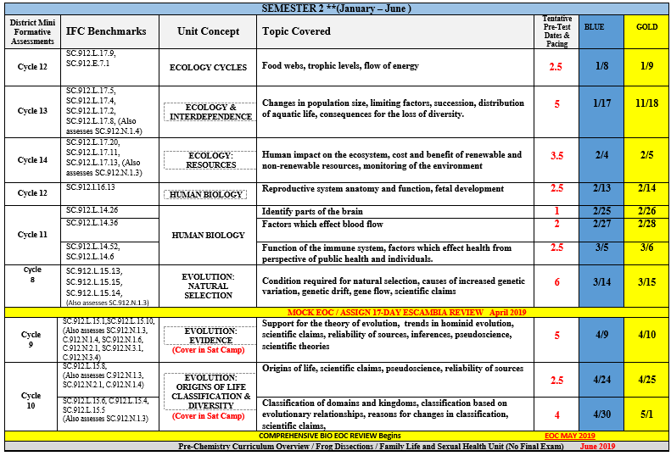

Grading Classwork, Homework and Testing are allotted points based on their complexity. Grading is done on a total point system and includes class work, homework, quizzes, pop quizzes and tests. Quizzes will be given based on the topic that is currently being studied and may or may not be announced (pop quizzes) prior to the quiz. Assignments, due dates and grades can be monitored in Pinnacle Internet Viewer.

Grading Policy:
90-100 A 70-76 C
87-89 B+ 67-69 D+
80-86 B 60-66 D
77-79 C+ <60 F

PINNACLE INTERNET VIEWER (PIV): gb.browardschools.com/pinnacle/gradebook
Directions:
- Start at the home page of your Internet browser
- Navigate to Lauderhill 6-12 web site at http://lauderhill612.browardschools.com/
- Click on the “Links” button at the top of the school website.
- From the drop down box, click on “Pinnacle”
- Follow the log-on instructions to enter the secure login information shown below:
Login ID: Student ID@my.browardschools.com (on student schedule)
Student’s Password: Capital ‘P’ + Birth date as _ _/_ _/_ _ _ _
(for example: January 2, 1993= P01/02/1993)

If you cannot see the menu bar to get to check grades try this direct link:
gb.browardschools.com/pinnacle/gradebook

NOTES:
- The login ID and password confidentiality is crucial- Do NOT give other people access.
- Please allow teachers turnaround time to enter grades.
Pinnacle Grade Codes
X | Excused | From the assignment; grade is not affected by this assignment.
Z | Zero | Student did NOT turn in assignment.
0 | Zero | Student turned the assignment in but did not receive any credit.
 | Blank Space | Means that the assignment was added into the computer, but not yet graded

Grade Category
*All assignment grades will be calculated based on a point system.
Tests / Labs
Classwork
Quizzes
Projects
Class Participation/HW/Warm-Up

*Ms. Barnett’s Grades Guarantee: You have full control over your success. I will not alter any grade based on request or proximity to a desired level. Every decision you make throughout the year will lead to a predictable outcome with criteria that is consistent for every student.

Keys to Ms. Barnett’s Class:

Think. Work. Be involved. Be consistently curious. LEARN. You will thrive!

Required Assignments: There will be approximately 10 Care Assessments and additional quizzes and tests during the course as well as various performance based assessments that require writing, research, and creativity. The number of formative grades such as quizzes, homework, etc. will be determined along the course of the school year. Students should expect a homework assignment each week and should look over notes and new material each day.

Items needed for class: Pens/pencils, paper, 5-subject notebook, folder, a highlighter, ATP - energy (in the form of Adenosine Triphosphate as well as mental focus)

Extra Help: Instructional Focus—this is a GREAT time for small group help; ask me for a pass! I am available several mornings a week. Please make an appointment ahead of time so that I can devote my full attention to your needs. Additionally, push-ins and pull-outs will be required for all Biology students.

Makeup Work: When students are absent from school, they are responsible for all missed work and
assessments. Students should check the class website immediately and the “Wall of Wisdom” where all handouts and materials are placed each day.

A student who is absent on the class day immediately before a regularly scheduled assessment/assignment will be responsible for completing the assessment/assignment on the
regularly scheduled day and time.

Students who have been absent more than two consecutive days (including the assessment day) will be given five (5) school days to make up the assessment and/or other assignments. This does not include major projects, research papers, tests, etc. where the deadline/date has been posted in advance. The teacher has the discretion to grant a longer period of time to make up work if there are extenuating circumstances.

A daily update of everything done in class and access to files used will be posted on the class website. Check it every day!

Late Work: Homework must be completed on the day it is due. Long-term projects must be turned in on the previously scheduled date. If a student is absent on that day, they must turn in the assignment the day they return to possibly receive full credit. For every day late thereafter, their highest possible grade will be a 70% / C. All other late work will be handled on a case-by-case basis: students must see me in extenuating circumstances.

*Formative Assessments include, but are not limited to homework, classwork, labs, quizzes, practice tests,  rough drafts, and sections of projects/ research  papers/presentations. | *Summative Assessments include, but are not limited  to unit tests, final projects, final essays, final research  papers, and final presentations.
-Work Habits will also be evaluated every term based on the categories of Responsibility, Participation,
Assignment Completion, & Interpersonal Skills.
Course Syllabus, Classroom Rules, and Policies for Biology

This page must be returned!

Please indicate by circling and initialing on the line provided:

My student does or does not have reliable access to a computer with internet. ___

My student does or does not have access to a working printer. ___

By signing below I confirm that I have read and understand the Course Syllabus, Classroom Rules, and Policies for Biology.

Instructor: Ms. Renee Barnett Class Period: ___________

*Please PRINT legibly.

Student Name
Phone
Email
Signature

Parent / Guardian Name
Phone
Email
Signature

