Plant Structure & Function Project 10/18/2016
You will prepare a report on at least 10 naturally occurring plants in the area in which you live. Technology (PowerPoint / Prezi, video, etc.) or Poster-board (include photos or illustrations). Be creative!
Report must include:
- Biome, ecosystem, and plant and animal interactions
- Plant information such as water requirements and seed dispersal and/or reproductive method
*Bonus: Include Scientific Names of plants (5 points)

Name:
Presentation Title:

4pts | 3pts | 2pts | 1pt
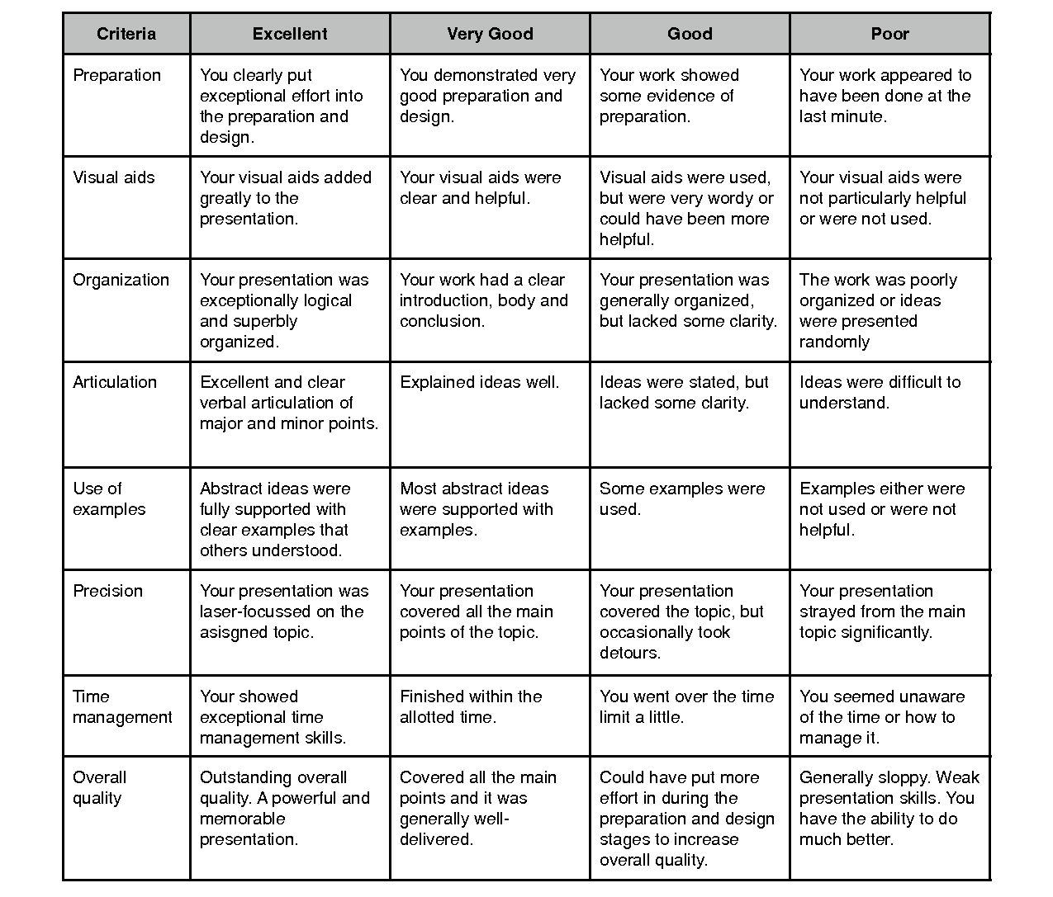

Plants | 10 or more | 6-9 | 3-5 | 3 and under
Plant Requirements | 10 or more | 6-9 | 3-5 | 3 and under
Biome | 10 or more | 6-9 | 3-5 | 3 and under
Animal  Interactions | 10 or more | 6-9 | 3-5 | 3 and under
Due Date: _________________ Total points ____ / 48

